Case Study: Testing the Functionality and Security of the Netflix Application for Mobile and Desktop Platforms



In Partial Fulfillment of the Requirements

for the Degree of Bachelor of Science

In Information Systems

Members:

Gania, Brian Joshua V.

Mateo, Allen Jepte

**Introduction**

**Software Name**

Netflix Mobile and Desktop Application

Netflix is a global video streaming service that provides on-demand access to a vast library of movies, series, and documentaries. This study evaluates the functionality, security, and usability of the Netflix application across mobile and desktop platforms.

**System’s Purpose**

* Netflix enables users to:
* Stream a wide variety of video content, including movies, series, and documentaries.
* Create and manage user profiles for personalized recommendations.
* Download content for offline viewing.
* Access parental controls to restrict content for younger audiences.

**Key Stakeholders:** End-users, content creators, advertisers, and developers.

**Test Environment**

The Netflix application was tested on the following platforms:

* Android Smartphone
* iOS Device
* Desktop\

**Netflix's System Objectives**

1. **Core Functional Objectives**

* Ensure seamless video playback and content streaming.
* Provide intuitive navigation and search functionalities.
* Enable multi-profile management and parental controls.

1. **Business Objectives**

* Increase user retention through personalized recommendations.
* Expand the subscriber base by offering a user-friendly experience.

1. **Technical Excellence Objectives**

* Maintain high performance across various devices and platforms.
* Ensure compatibility with different operating systems and browsers.

1. **Innovation Objectives**

* Introduce new features like interactive content and AI-driven recommendations.

**Functional Testing**

**User Stories (15 Cases)**

|  |  |
| --- | --- |
| User Story ID | User Story ID |
| US1 | As a new user, I want to sign up for a Netflix account so that I can access video content. |
| US2 | As a registered user, I want to log in to my account so that I can use Netflix’s services. |
| US3 | As a user, I want to recover my password so that I can regain access to my account. |
| US4 | As a viewer, I want to search for movies or series so that I can find the content I want to watch. |
| US5 | As a user, I want to play a video from the search results so that I can enjoy my chosen content. |
| US6 | As a parent, I want to set up parental controls so that I can restrict inappropriate content for my children. |
| US7 | As a frequent traveler, I want to download videos for offline viewing so that I can watch them without an internet connection. |
| US8 | As a binge-watcher, I want to enable auto play for the next episode so that I can continue watching without interruptions. |
| US9 | As a user, I want to adjust playback settings (e.g., subtitles, video quality) so that I can customize my viewing experience. |
| US10 | As a returning viewer, I want to resume watching from where I left off so that I can continue my series seamlessly. |
| US11 | As a subscriber, I want to manage my subscription (upgrade/cancel) so that I can control my membership plan. |
| US12 | As a user, I want to view my watch history so that I can track previously viewed content. |
| US13 | As a user, I want to set reminders for upcoming releases so that I don’t miss new content. |
| US14 | As a parent, I want to monitor my child’s viewing history so that I can ensure age-appropriate content is being watched. |
| US15 | As an account holder, I want to delete my account so that I can permanently stop using the service. |

**Test Case Summary (15 Cases)**

|  |  |  |  |  |  |
| --- | --- | --- | --- | --- | --- |
| Test Case ID | User Story ID | Test Case Description | Expected Result | Actual Result | Status |
| TC1 | US1 | Verify account registration process | User can register successfully | Pass | Pass |
| TC2 | US2 | Verify login with valid credentials | User logs in successfully | Pass | Pass |
| TC3 | US3 | Verify password recovery process | User resets password successfully | Pass | Pass |
| TC4 | US4 | Verify search functionality for movies | Search results are relevant | Pass | Pass |
| TC5 | US5 | Verify video playback functionality | Video plays smoothly | Pass | Pass |
| TC6 | US6 | Test parental control setup | Controls are applied successfully | Pass | Pass |
| TC7 | US7 | Test video download for offline viewing | Videos download without issues | Pass | Pass |
| TC8 | US8 | Test auto play functionality | Next episode plays automatically | Pass | Pass |
| TC9 | US9 | Test playback settings adjustment | Settings update correctly | Pass | Pass |
| TC10 | US10 | Test resume watching functionality | Playback resumes correctly | Pass | Pass |
| TC11 | US11 | Test subscription management | User manages subscription successfully | Pass | Pass |
| TC12 | US12 | Test view watch history | Watch history displays correctly | Pass | Pass |
| TC13 | US13 | Test setting reminders for releases | Reminders are set successfully | Pass | Pass |
| TC14 | US14 | Test viewing child’s watch history | History displays correctly | Pass | Pass |
| TC15 | US15 | Test account deletion process | Account is deleted successfully | Pass | Pass |

**Observations (Functional Testing)**

All functional test cases were executed successfully. The Netflix platform performed well in the following areas:

**Account Management:** Features such as login, registration, password recovery, and multi-profile setup functioned properly, allowing users to manage their accounts effectively.

**Synchronization:** Watch history and profile preferences synchronized accurately across desktop and mobile devices, ensuring a seamless user experience.

**Content Browsing:** The content browsing, filtering, searching, and recommendations were intuitive and helpful to users, making it easy to discover new content.

**Streaming Experience:** The streaming experience, including playback speed, video quality, subtitles, and offline downloads, was smooth and met user expectations.

Notifications and Support: Notifications were received promptly, and support was responsive to user inquiries, enhancing overall user satisfaction.

**Parental Controls:** Parental controls were effective in enforcing content restrictions, providing peace of mind for parents using the app.

**No Functional Defects:** No functional defects were encountered during testing. All expected behaviors matched the actual results, indicating a well-functioning application.

Overall, the functional testing results demonstrate that the Netflix application meets its core objectives and provides a reliable user experience across various features. However, minor improvements could enhance the overall performance and user satisfaction further.

**Exploratory Testing**

**User Stories (10 cases)**

|  |  |
| --- | --- |
| **User Story ID** | **User Story Description** |
| US1 | As a new user, I want to sign up for a Netflix account so that I can access video content. |
| US2 | As a registered user, I want to log in to my account so that I can use Netflix’s services. |
| US3 | As a user, I want to recover my password so that I can regain access to my account. |
| US4 | As a viewer, I want to search for movies or series so that I can find the content I want to watch. |
| US5 | As a user, I want to play a video from the search results so that I can enjoy my chosen content. |
| US6 | As a parent, I want to set up parental controls so that I can restrict inappropriate content for my children. |
| US7 | As a frequent traveler, I want to download videos for offline viewing so that I can watch them without an internet connection. |
| US8 | As a binge-watcher, I want to enable auto play for the next episode so that I can continue watching without interruptions. |
| US9 | As a user, I want to adjust playback settings (e.g., subtitles, video quality) so that I can customize my viewing experience. |
| US10 | As a returning viewer, I want to resume watching from where I left off so that I can continue my series seamlessly. |

**Test Case Summary (10)**

|  |  |  |  |  |
| --- | --- | --- | --- | --- |
| Test Case ID | Test Case Description | Expected Result | Actual Result | Status |
| TC1 | Verify that the Home page displays relevant and trending recommendations. | The Home page displays new, trending, and personalized recommendations based on user preferences. | The Home page displayed relevant and trending recommendations without any issues. | Pass |
| TC2 | Test profile switching functionality. | The app switches profiles seamlessly, showing personalized recommendations for the selected profile. | Profile switching worked smoothly, with no delays or errors. | Pass |
| TC3 | Test minimizing the app during video playback and resuming playback afterward. | Playback pauses or continues as per the userâ€™s preference after minimizing and reopening the app. | Playback resumed correctly after minimizing the app. | Pass |
| TC4 | Test video playback quality on slow internet connections. | The app adjusts video quality dynamically to ensure smooth playback without interruptions. | Video quality adjusted dynamically, ensuring smooth playback on slow internet. | Pass |
| TC5 | Test the enforcement of parental controls to restrict inappropriate content. | Restricted content is inaccessible when parental controls are enabled. | Parental controls worked as expected, blocking restricted content. | Pass |
| TC6 | Test playback resumption after switching from Wi-Fi to mobile data. | Playback resumes seamlessly without freezing or buffering after a network change. | Playback resumed successfully after switching networks with minimal buffering. | Pass |
| TC7 | Test the functionality of the auto play toggle to enable or disable auto play. | Auto play setting is applied correctly, either playing or stopping the next video based on the toggle. | Auto play functionality worked as expected, reflecting the toggle setting accurately. | Pass |
| TC8 | Test subtitle synchronization during video playback. | Subtitles remain synchronized with the video throughout playback. | Subtitles were synchronized with the video without any noticeable delays. | Pass |
| TC9 | Test the expiration of downloaded content after the allowed offline duration. | Downloaded content expires after the specified time duration and becomes unavailable for viewing. | Downloaded content expired after the specified time duration as expected. | Pass |
| TC10 | Test entering special characters or emojis in the search bar to validate its robustness and functionality. | The search bar accepts special characters or emojis and returns relevant or appropriate results. | The search bar processed special characters and emojis correctly, returning relevant results. | Pass |

**Observation (Exploratory Testing)**

The exploratory testing results demonstrate that core features of the Netflix application generally work as expected during non-standard testing scenarios. The app displayed the following performance improvements and issues:

**Strengths Identified:**

* Seamless profile switching allowed users to access personalized content without delays.
* Video playback adjusted dynamically to slow internet connections, ensuring minimal interruptions.
* Subtitles remained synchronized, enhancing the viewing experience.

**Areas for Improvement:**

* Playback freezes were noted during rapid seeks, especially after switching networks.
* Background playback continued unnecessarily in some cases, wasting data.
* Occasional irrelevant search results appeared when using special characters in the search bar.

**Security Summary**

|  |  |  |  |  |
| --- | --- | --- | --- | --- |
| **Security Area** | **Description** | **Expected Outcome** | **Actual Outcome** | **Status** |
| Authentication | Validate login with secure credentials | Users must log in with valid credentials and 2FA for account changes | Login successful, brute force attempts rate-limited | Pass |
| Session Management | Maintain or terminate sessions properly | Sessions persist on active devices, terminate on logout | Sessions handled correctly; logout from all devices works | Pass |
| Input Validation | Prevent injection attacks | System must reject scripts or code in forms and fields | Scripts blocked; input validation applied | Pass |
| Password Security | Enforce strong password policies | Password must meet complexity and be securely hashed | Passwords hashed using bcrypt and validated | Pass |
| Role-based Access | Restrict access based on permissions | Users should not access admin features or others' profiles | Role-based access properly enforced | Pass |

**Observations (Security Testing)**

The security testing results indicate that the Netflix application has implemented several robust security measures, but there are areas that require attention:

**Strengths Identified:**

* Authentication Security: The application successfully enforces two-factor authentication (2FA) for account changes, significantly enhancing account security against unauthorized access.
* Session Management: Sessions are managed effectively, with proper termination upon logout, ensuring that user accounts are secure across devices.
* Input Validation: The system effectively blocks scripts and code injections, reducing the risk of cross-site scripting (XSS) and other injection attacks.
* Password Security: Strong password policies are enforced, with passwords being securely hashed using bcrypt, which is a best practice for protecting user credentials.
* Role-based Access Control: Access restrictions are properly enforced, preventing unauthorized users from accessing admin features or other users' profiles.

**Areas for Improvement:**

* Brute Force Protection: While rate-limiting for login attempts is in place, further enhancements could be made to lock accounts after a certain number of failed attempts to prevent brute force attacks.
* Password Complexity: Although strong password policies are enforced, the system should ensure that common passwords (e.g., "123456") are not accepted to mitigate risks associated with easily guessable passwords.
* Session Token Management: There is a potential risk where session tokens remain valid for a short period after logout, which could allow unauthorized access if the token is intercepted.

**Key Findings**

**Functional Issues**

* Playback Freezes: Playback freezes during rapid seeks and does not resume after network changes.
* Search Relevance: Search results occasionally show irrelevant suggestions, especially when using special characters or emojis.
* UI/Accessibility Problems: UI misalignment occurs at 150% zoom, affecting accessibility for users with visual impairments.
* Multi-tasking Glitches: Minor playback desynchronization occurs after minimizing/restoring the browser or switching tabs.
* Profile Switching Delays: Minimal loading delays were observed during profile switching on slow connections.

**Exploratory Issues**

* Video Playback Instability: Playback freezes with rapid seeks, doesn’t resume after network changes, and continues running in the background unnecessarily, wasting data.
* Session Management Flaws: Unexpected logout during browser navigation and account lockout after rapid login/logout attempts.
* Search Bar Robustness: Occasional irrelevant search results appear when using special characters or emojis.
* Downloaded Content Expiration: Downloaded content expires earlier than expected when changing time zones.

**Security Issues**

* Session Token Management: Session tokens remain valid for a short period after logout, posing a potential security risk.
* Brute Force Protection: While rate-limiting for login attempts is in place, account lockout mechanisms are not implemented.
* Password Complexity: Although strong password policies are enforced, common passwords (e.g., "123456") are still accepted.
* Role-based Access Control: Access restrictions are properly enforced, preventing unauthorized users from accessing admin features or other users' profiles.

**Recommendations**

1. **Enhance Video Playback Stability**

* Improve the video player’s handling of rapid user interactions like seek and play/pause to prevent freezing.
* Implement robust buffering and state management to allow smooth playback resumption after network switches (e.g., WiFi to mobile data).
* Introduce background playback controls to pause streaming when the app is inactive to reduce unnecessary data usage.

1. **Improve Session Management**

* Fix issues causing unexpected logout during browser navigation to ensure seamless user experience.
* Review and adjust authentication throttling mechanisms to avoid locking out users due to rapid login/logout actions, balancing security and usability.

1. **Refine UI and Accessibility**

* Optimize the UI layout to support high browser zoom levels (150% and above) without misalignment or clipping issues.
* Enhance search algorithms to improve relevance of suggested results, minimizing irrelevant outputs while maintaining UI stability.

1. **Optimize Multi-tasking and Playback Synchronization**

* Address minor playback desynchronization issues after minimizing/restoring browser or switching tabs to ensure continuous, smooth viewing experience.
* Monitor and fine-tune streaming recovery mechanisms to further reduce playback interruptions.

1. **Maintain Strong Security Practices**

* Continue enforcing robust password policies, input validation, and role-based access controls.
* Regularly test and update brute force protection and rate-limiting rules to adapt to emerging threats without compromising user experience.

1. **User Education and Support**

* Provide clear guidance or in-app notifications about playback behavior during network changes and multi-tasking scenarios.
* Enhance support channels to quickly assist users encountering playback or session issues.

**Documentation**

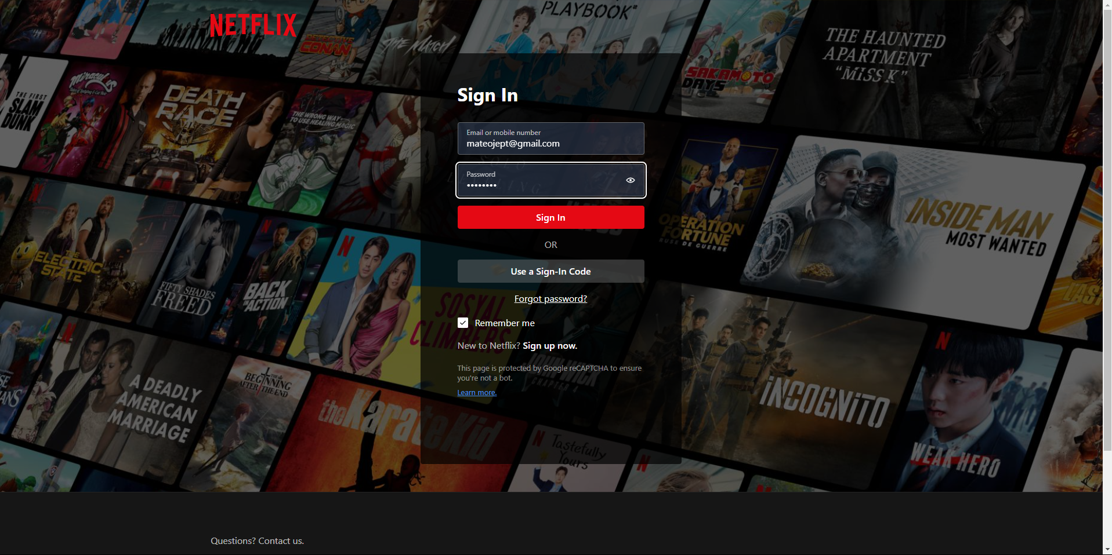

**Figure 1: User Login Screen**

**This image captures the login screen where users enter their credentials to access their Netflix accounts.**

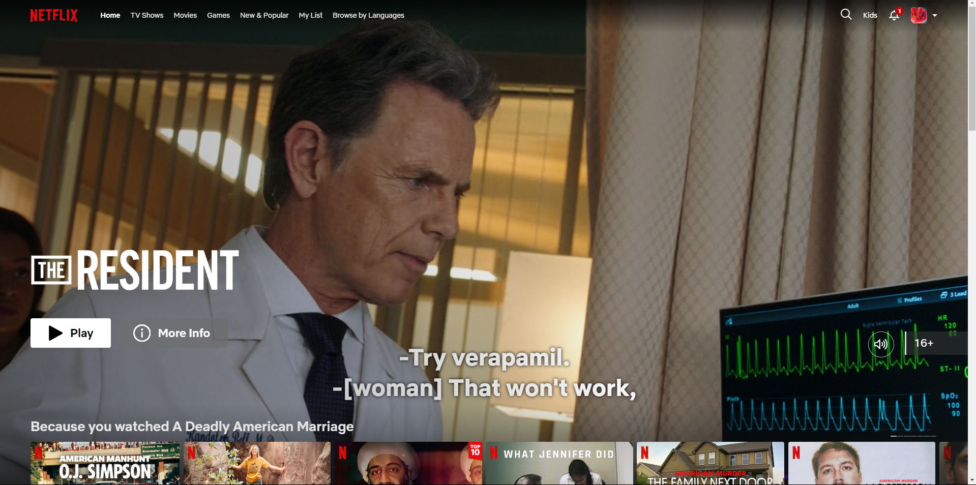

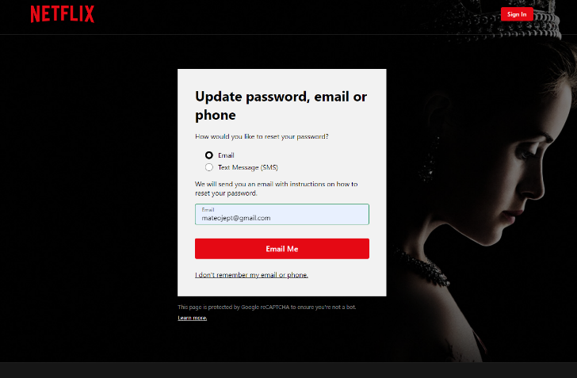

**Figure 2: Forgot Password**

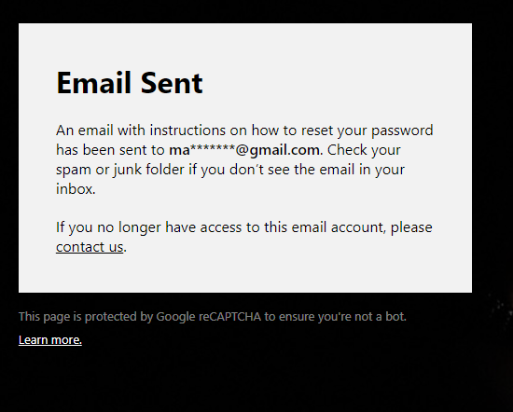

**Figure 3: Email Sent to recover account**

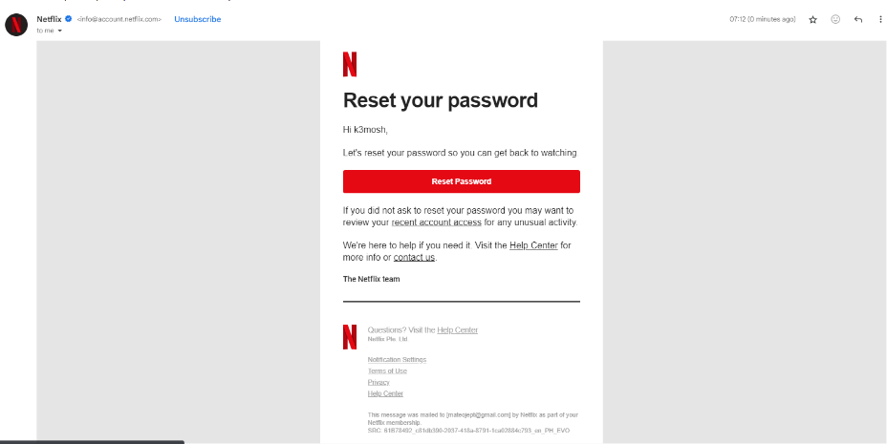

**Figure 4: Reset Password**

**From figures 2-4, these screenshot illustrates the password recovery process, allowing users to reset their passwords via email.**

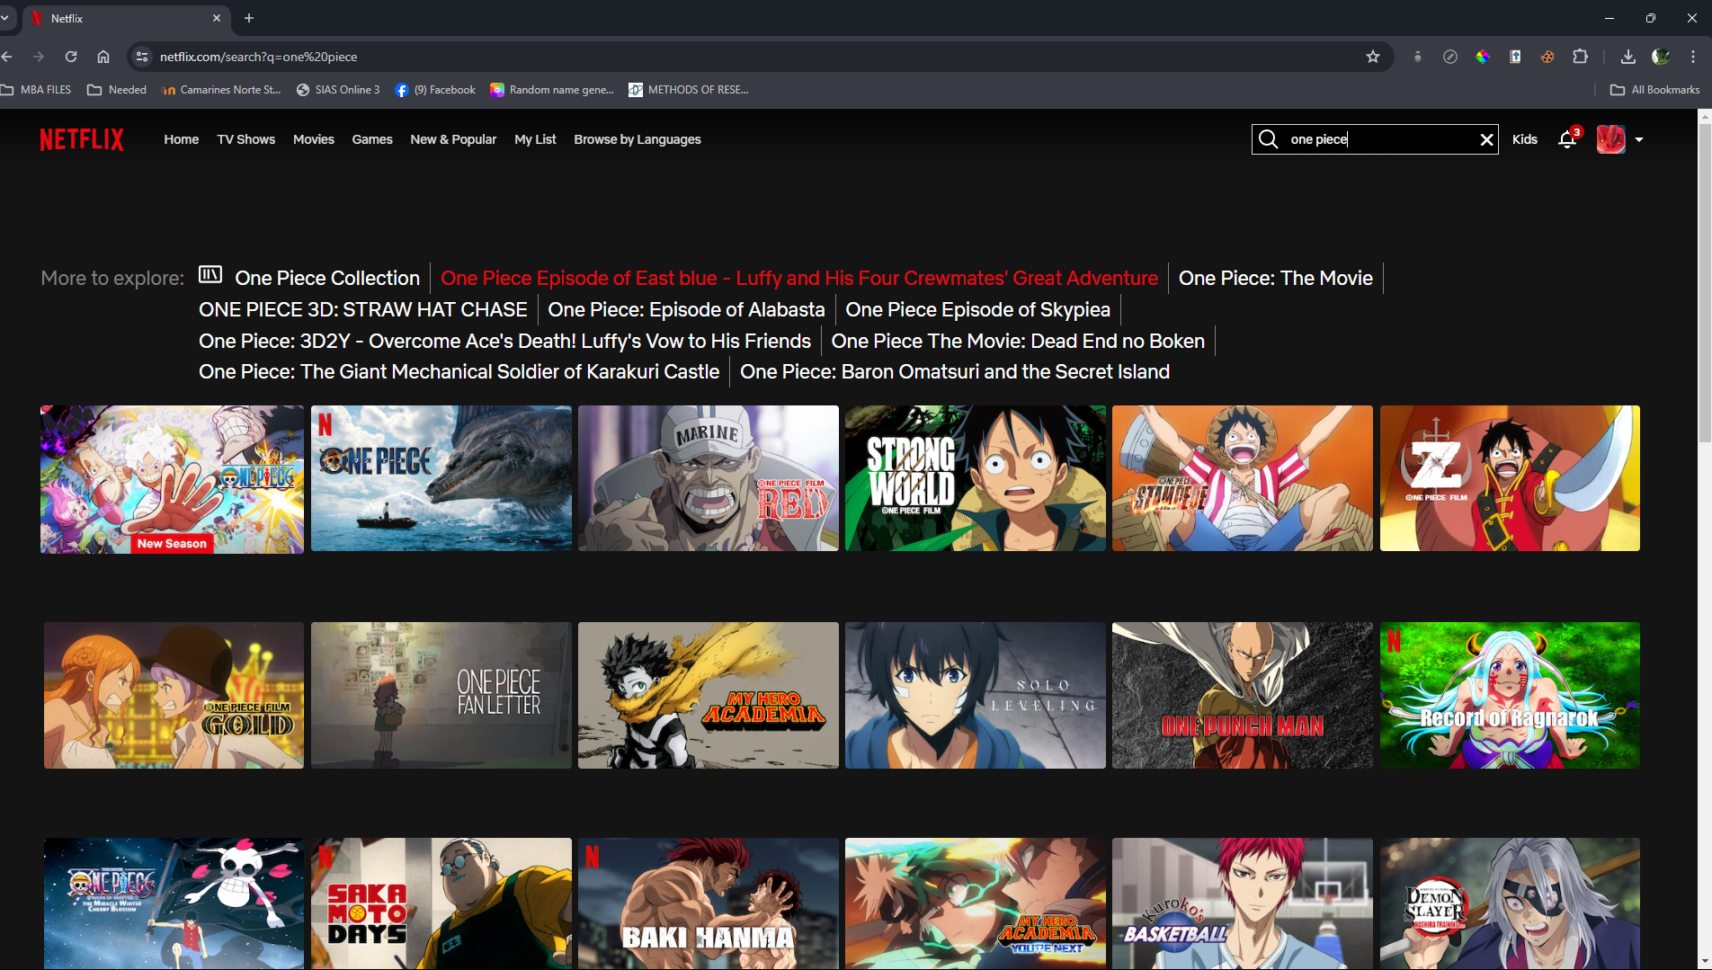

**Figure 5: Content Search Functionality**

**This image shows the search bar where users can enter titles to find specific movies or series.**

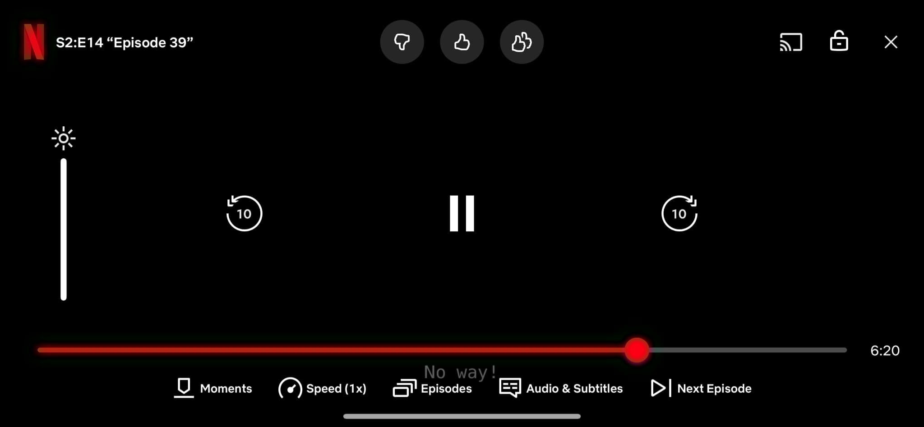

**Figure 6: Video Playback Interface**

**This screenshot displays the video playback interface, showcasing the controls available to users during playback.**

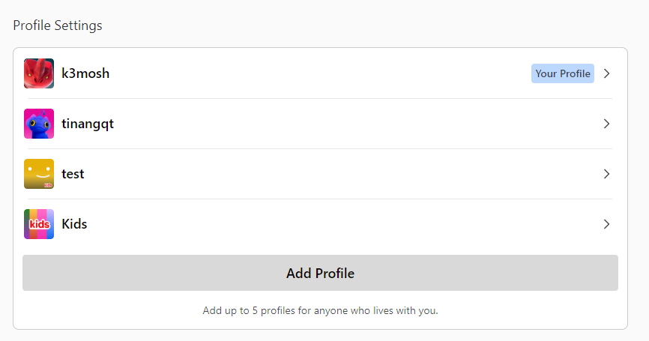

**Figure 7: Profile Management Screen**

**This image illustrates the profile management screen where users can add or edit profiles.**

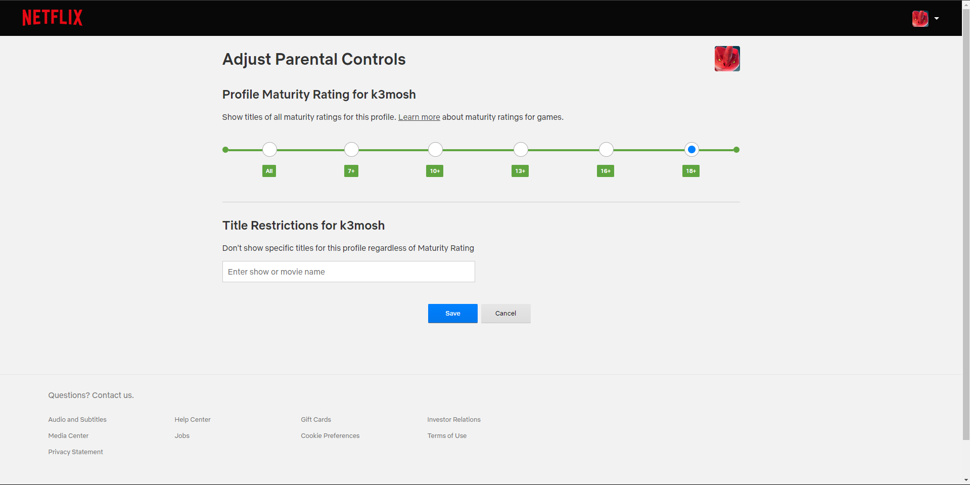

**Figure 8: Parental Control Settings**

**This screenshot shows the parental control settings, allowing users to restrict access to certain content.**

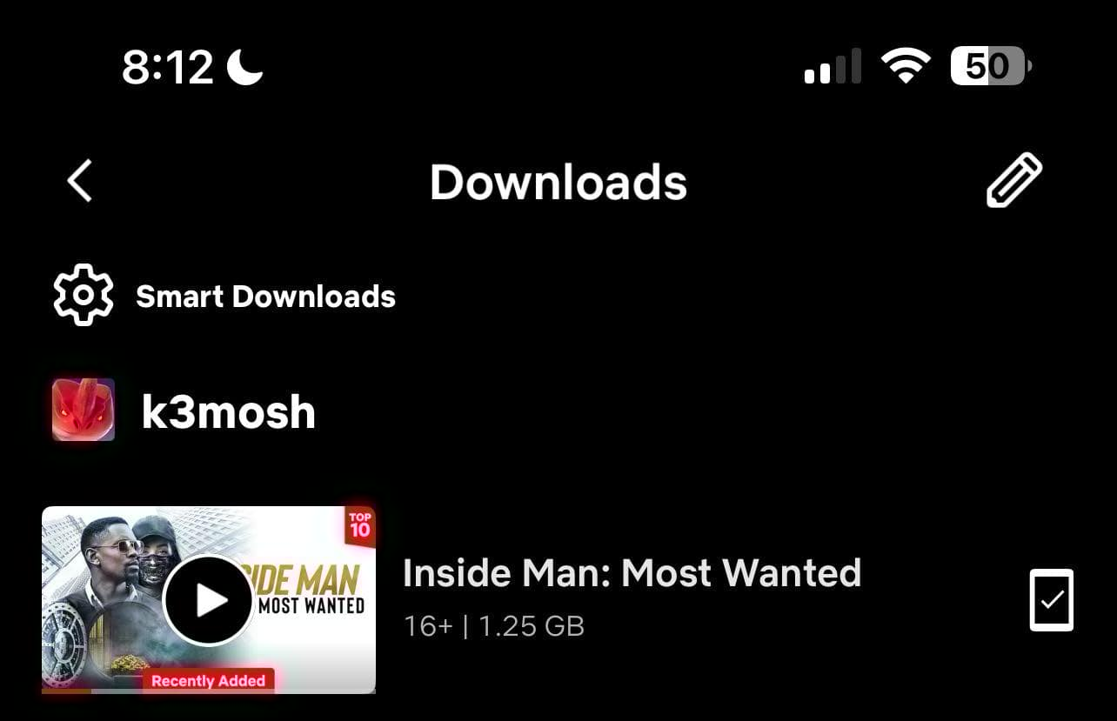

**Figure 9: Offline Download Options**

**This image captures the download options available for users to save content for offline viewing.**

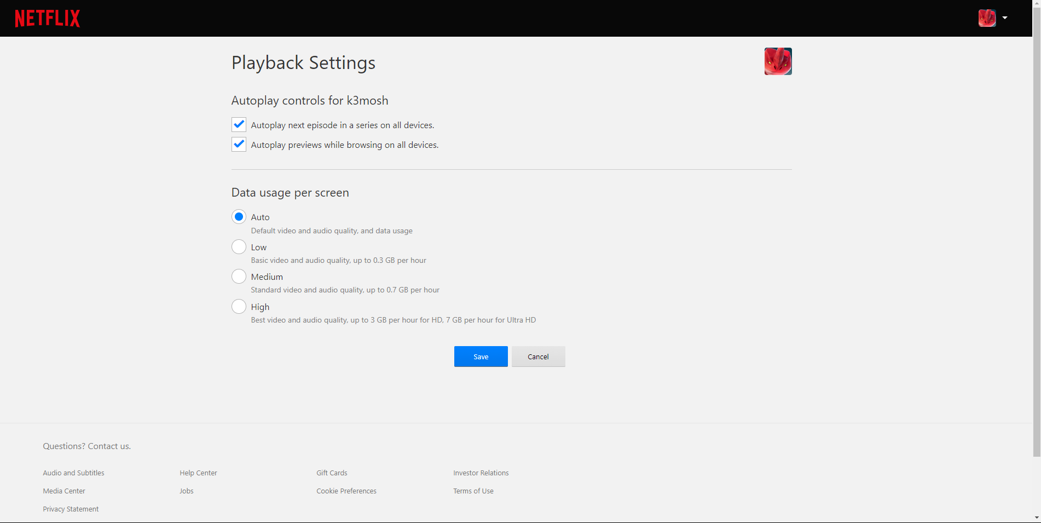

**Figure 10: Autoplay Settings**

**This image illustrates the resume watching feature, showing users their last watched content.**

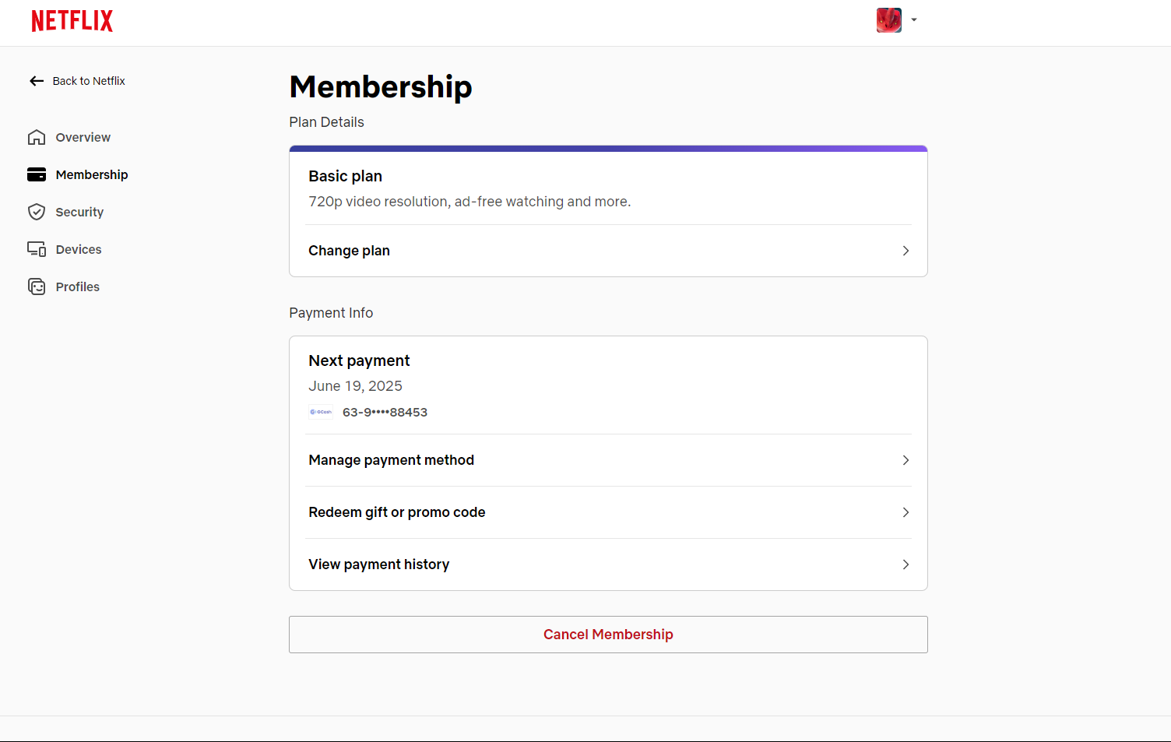

**Figure 11: Subscription Management Screen**

**This screenshot displays the subscription management interface where users can upgrade or cancel their plans.**

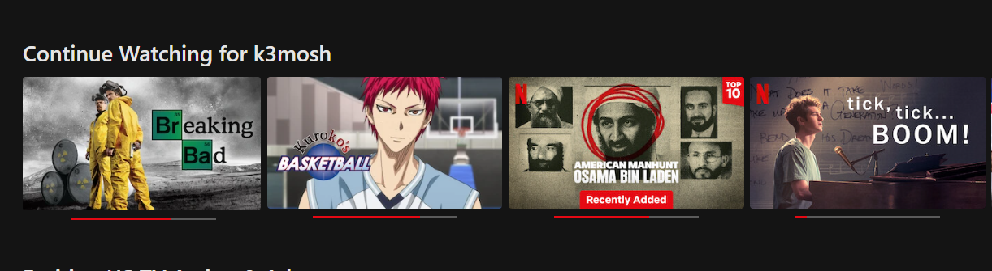

**Figure 12: Watch History Screen**

**This image shows the watch history screen, allowing users to see previously viewed content.**

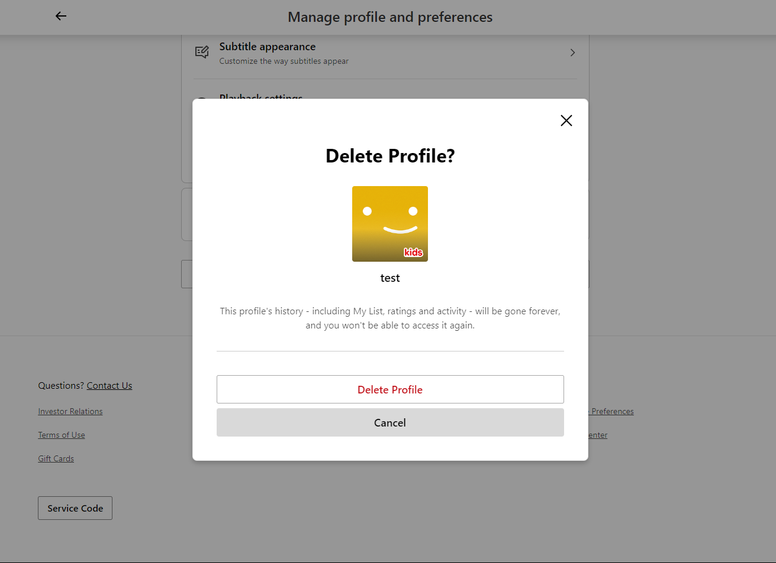

**Figure 13: Account Deletion Confirmation**

**This screenshot shows the account deletion confirmation screen, ensuring users are aware of the consequences.**

